 Cybersecurity
Project 1 Technical Brief

Make a copy of this document before you begin. Place your answers below
each question. This completed document will be your deliverable for Project 1. Submit it through Canvas when you’re finished with the project at the end of the week.

Your Web Application

Enter the URL for the web application that you created:

https://joelssecurityresume.azurewebsites.net/

Paste screenshots of your website created (Be sure to include your blog posts):

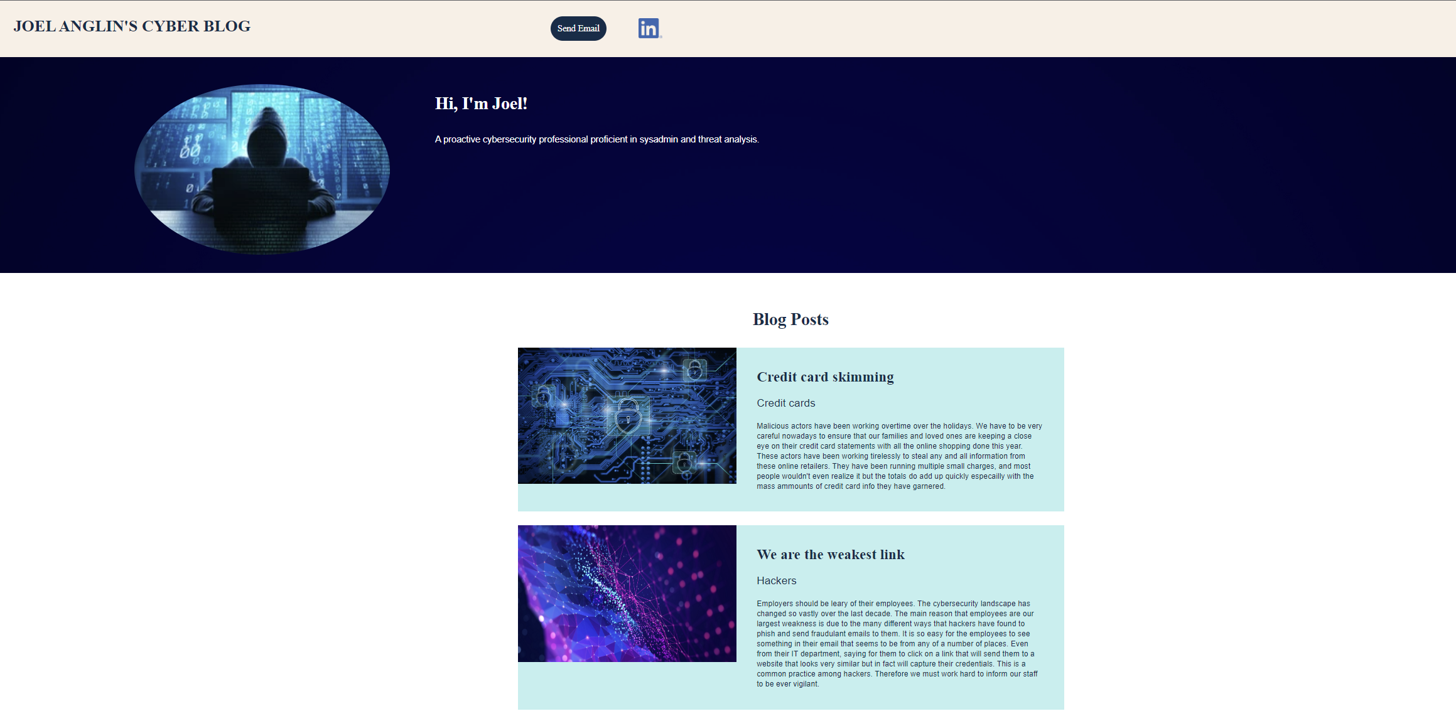

Day 1 Questions

General Questions

- What option did you select for your domain (Azure free domain, GoDaddy domain)?

Azure free domain

- What is your domain name?

joelssecurityresume.azurewebsites.net

Networking Questions

- What is the IP address of your webpage?

20.119.8.24

- What is the location (city, state, country) of your IP address?

Lewisville, Texas, USA

- Run a DNS lookup on your website. What does the NS record show?
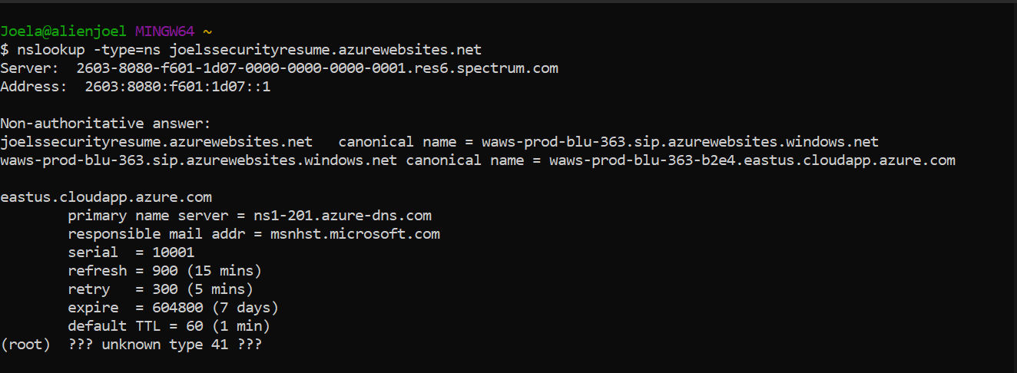

Web Development Questions

- When creating your web app, you selected a runtime stack. What was it? Does it work on the front end or the back end?

PHP 8.0 and it works on the backend but there are better options

- Inside the /var/www/html directory, there was another directory called assets. Explain what was inside that directory.

There is an image directory and a css directory which is for the formatting of the websites

- Consider your response to the above question. Does this work with the front end or back end?

This would be the front end because this is what everyone else would see

Day 2 Questions

Cloud Questions

- What is a cloud tenant?

Someone who purchases cloud based assets

- Why would an access policy be important on a key vault?

Because it would let you know who has access to the actual keys

- Within the key vault, what are the differences between keys, secrets, and certificates?

Secrets are for the storage of passwords and confidential info, keys can manage azure storage info internally and can periodically rotate them. Certificates are built on top of keys and secrets and add an automated renewal feature.

Cryptography Questions

- What are the advantages of a self-signed certificate?

Self-signed certificates are fast, free, and easy to issue

- What are the disadvantages of a self-signed certificate?

Since a publicly trustworthy CA does not sign self-signed certificates, browsers and operating systems do not trust them. Browsers wouldn’t display the green lock icon or other trust-related visual cues.

- What is a wildcard certificate?

A SSL/TLS Wildcard certificate is a single certificate with a wildcard character (*) in the domain name field. This allows the certificate to secure multiple sub domain names (hosts) pertaining to the same base domain

- When binding a certificate to your website, Azure only provides TLS versions 1.0, 1.1, and 1.2. Explain why SSL 3.0 isn’t provided.

Ssl 3.0 is out of date and riddled with vulnerabilities so is out of circulation.

- After completing the Day 2 activities, view your SSL certificate and answer the following questions:

  - Is your browser returning an error for your SSL certificate? Why or why not?

It is running just fine because azure provided it.

  - What is the validity of your certificate (date range)?

Sept 16, 2022 and oct 11 2023

  - Do you have an intermediate certificate? If so, what is it?

Yes it is a Microsoft Azure TLS issuing CA 01

  - Do you have a root certificate? If so, what is it?

DigiCert Global Root G2

  - Does your browser have the root certificate in its root store?

Yes it does

  - List one other root CA in your browser’s root store.

Here is another CN=CA Disig Root R2,O=Disig a.s.,L=Bratislava,C=SK

Day 3 Questions

Cloud Security Questions

- What are the similarities and differences between Azure Web Application Gateway and Azure Front Door?

Both are layer 7 though Front Door is non-regional and Azure Web Application is regional

- A feature of the Web Application Gateway and Front Door is “SSL Offloading.” What is SSL offloading? What are its benefits?

It is the process of removing the SSL-based encryption from incoming traffic so the web server doesn’t have to expend extra processing power on decrypting

- What OSI layer does a WAF work on?

Layer 7 defense though it’s not suited for the defense of all attacks, but better suited as a tool in your belt to help in some attacks.

- Select one of the WAF managed rules (e.g., directory traversal, SQL injection, etc.), and define it.

Sql injection rule statement is looking for malicious SQL code. Attackers insert malicious SQL code into web requests in order to do things like modify your database or extract data from it.

- Consider the rule that you selected. Could your website (as it is currently designed) be impacted by this vulnerability if Front Door wasn’t enabled? Why or why not?

There is no way for them to use sql injection on my website, and this is because there is no true input available for them to give for this.

- Hypothetically, say that you create a custom WAF rule to block all traffic from Canada. Does that mean that anyone who resides in Canada would not be able to access your website? Why or why not?

I’d say that even if you create a custom WAF rule to block from canada, that there would still be ways to get into it with a vpn or other methods.

- Include screenshots below to demonstrate that your web app has the following:

  - Azure Front Door enabled

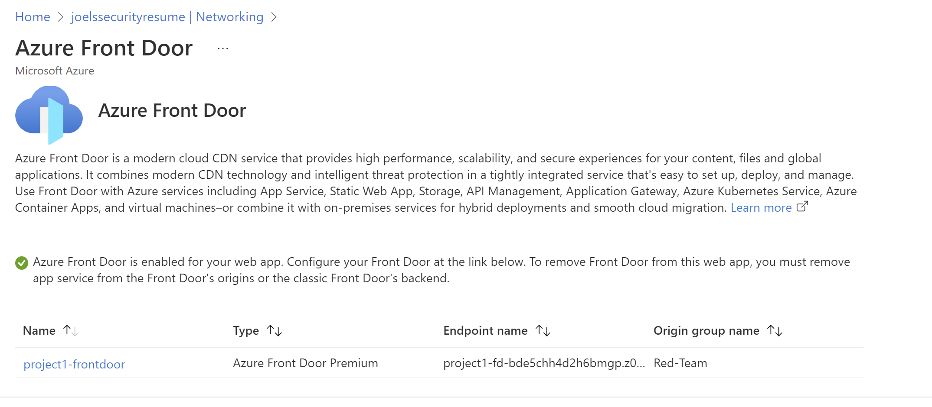

  - A WAF custom rule

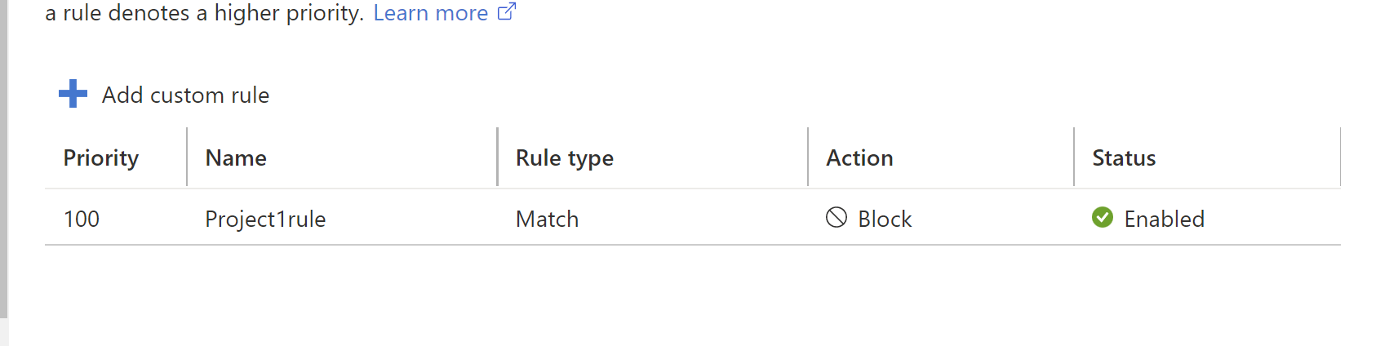

Disclaimer on Future Charges

Please type “YES” after one of the following options:

- Maintaining website after project conclusion: I am aware that I am responsible for any charges that I incur by maintaining my website. I have reviewed the guidance for minimizing costs and monitoring Azure charges.

- Disabling website after project conclusion: I am aware that I am responsible for deleting all of my project resources as soon as I have gathered all of my web application screen shots and completed this document.

© 2022 Trilogy Education Services, a 2U, Inc. brand. All Rights Reserved.

